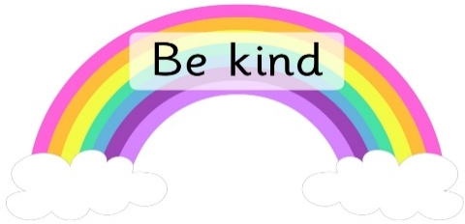
Think of Others Thursday

Complete one of the following activities (or as many as you like!)

- It is nice to be nice!
Choose three ‘Random Acts of Kindness’ from the board to complete this week.

- We know it is hard not seeing your school friends at the moment, but we will all be together again soon. I am trying to make a delicious recipe for a Friendship Pie! So far, I have 3 spoonfuls of kindness, a sprinkle of laughter and a pinch of patience! What other ingredients do you think would make a good Friendship Pie? (template attached).

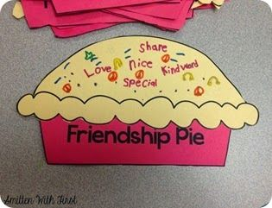

- I bet there is someone that you really miss and can’t wait to give them a big squeeze! Why not fill out a ‘Keep This Hug Safe’ form, so they know that you are thinking about them (template attached).

- Try the Bumblebee Breathing Technique as you think about all the wonderful people in your life.

