5th class last week of homework!!!
Monday 22nd-Thursday 25th June 2020
ENGLISH
- English in Practice: (15 mins per day) days 134-137 (If you like, you could try to finish the last days of the book by spending a few more minutes on this every day. I know it’s hard, but wouldn’t it be great to think you have the whole book done!? It’s up to you, no pressure!)
- My Spelling Workbook: (5 mins per day) this is the last week of spellings! By the end of this week, you will have completed the whole book AND revised the whole book too! Well done 5th class! Get your parents or a sibling to test you or get someone to ask you ANY spelling from your book!!! Click HERE for the spellings this week.
- Novel: (60 mins THIS WEEK) The Secret Garden- Frances Hodgson Burnett. We are finished our novel! Very well done 5th class!! Did you enjoy the book?
- Write a short account of why you did or did not enjoy this novel. Draw a picture of what you imagine your favourite or least favourite part/ character/ place looks like. Don’t forget to back up your answer with evidence from the novel.
- You can watch an old version of The Secret Garden HERE or click HERE to check out this trailer for the new movie which was due to be released in cinemas in March but I don’t think has been released yet! I am very much looking forward to watching it!

MATHS
- Mental Maths: week 36 (including problem solving & Friday review)
- Mathemagic 5:
Chapter 40- Chance- page 167-172 and Chapter 41+43- Problem Solving 3+4
As this is our last week, I am choosing some nice, easy, fun chapters to finish on. We didn’t get to finish Capacity, Mental Strategies 3, Maths Trail or Number-to-Word Puzzles but don’t worry, I will leave a note for your 6th class teacher for September to tell her and you will be doing a lot of revision of 5th class topics. As always, if it is taking you too long, please just cut back and maybe try every second one instead.
  - Click HERE for a few questions on chance and probability.
  - There are lots of strategy and logic games on HERE
There are lots of Statistics and Probability, Logic and Problem Solving Games on HERE
- If you feel like doing a little bit of maths over the summer, even an hour a week, here are some good online Maths Games: Splash Learn / Math Playground / Cool Math Games
- Click HERE to learn a few fun card games like this one called ‘Spit’! You only need 2 players!

GAEILGE
Maith thú rang a cúig! Táimid críochnaithe leis Abair Liom 5!!
Well done 5th class! We are finished Abair Liom 5!
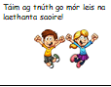

I hope you try to keep using Irish over the summer! Here are a few ideas:
- TV programme on TG4 - Cúla4 Ar Scoil -weekdays from 10-10.30am, click here to visit the website.
- Cúla 4 also have a Scéal an Lae (story of the day) each day click HERE
- Futa Fata have stories as Gaeilge every day: click HERE
- Explore these websites and try to use your Gaeilge at home to have simple conversations:
  - Seidean Sí/ Duo Lingo
- This website is a simple vocabulary builder and has simple vocabulary games:
click HERE
- There is a selection of other ideas on HERE

RELIGION
- Pope Francis - Prayer for Protection against Coronavirus- click here for online link.
- Grow in Love: Seasonal/ Additional: Lesson 5: LESSON 6 JUDAISM (II): PESACH AND THE SEDER MEAL
This is the last lesson in Grow in Love. We will have covered every lesson once we complete this chapter. Well done 5th class!
- You can access the online activities for this lesson by going to www.growinlove.ie insert this email address trial@growinlove.ie and password growinlove - choose Fifth class/P7, Seasonal/ Additional: Lesson 5: Lesson 6 Judaism (Ii): Pesach And The Seder Meal Read through pages 134-137. This chapter invites us to recall the stories of Abraham and Moses, explain what is celebrated at the Seder meal and to explain the links between the special Seder foods and the story of the Israelites’ escape from slavery in Egypt.
- Discuss what you learned this week with your parents/guardians.

Social, Environmental and Scientific Education (SESE)
Small World History: Unit 19 Irish Women in Science and Unit 20: Communication pages 92-103
- click here to view your textbook online

As we only have two chapters left in History, I am going to ask you to just read through both and write 5 interesting things you learned about Irish Women in Science and Communication. You can answer the questions in your book orally if you like or get a parent or sibling to ask you the questions once you have read the chapter but I don’t expect you to write out the answers. It is the last week of school after all!!!
As always, there is so much amazing information online, feel free to look up some of the websites below too if you like!

Unit 19 Irish Women in Science
Information about Kay McNulty http://en.wikipedia.org/wiki/Kay_mcnulty
Information about Kathleen Lynn http://en.wikipedia.org/wiki/Kathleen_Lynn
Information about Ireland’s greatest female inventors
http://www.siliconrepublic.com/innovation/item/33191-unit2013

Unit 20: Communication
Photographs of cave paintings in the Cave of Altimira, Spain
www.santillana-del-mar.com/english/altamira.htm
Biography of Johannes Gutenberg
www.ducksters.com/biography/johannes_gutenberg.php
Biography of Bill Gates
www.biography.com/people/bill-gates-9307520
Timeline of communication
http://inventors.about.com/library/inventors/bl_history_of_communication.htm

MUSIC:
- Music Generation: Here is the link again to the music lessons from Karl which he devised especially for 5th again- you could revisit it over the summer any day you have free time and keep practicing
https://msletb-my.sharepoint.com/:f:/g/personal/musicgenerationsligo_msletb_ie/EpKVTXFxKohGktYiiRsJ3NgBlcrLJOIKvVeMQt4KqU2wYg?e=Vi1upt
- Revise all the tin whistle tunes you learned so far during school closure
  - Amhrán Na bhFiann - Our National Anthem
  - The River Sáile
  - Spancil Hill (Waltz)
  - Molly Malone
  - Ireland’s Call
  - Harry Potter (Hedwig's Theme)
  - Baby Shark
  - Amazing Grace
- Remember to practice in a quiet place on your own, maybe in your room and be sure not to annoy other people in your house when you are practicing!

SPHE/Wellbeing/ P.E
This week is Active Sports Week and Wellbeing Week in Rockfield NS!
As you can see from the school blog, this week is Active Sports Week and Wellbeing Week. As Rockfield NS would usually be organising your Sports Day this week, Ms Scanlon is going to post you some sports and wellbeing activities on the blog each day that you may enjoy with your family at home. If you would like to email any fun photos of your activities, we would love to see and display them!
Other active Work:
- Body Coach: Continue your PE classes with the Body Coach who has become the world’s PE teacher! Children all over the world are participating in these classes! https://www.youtube.com/watch?v=Na1rzigYlSU&t=35s You will find his most recent videos on the sidebar of his channel.
- Twinkl e-sports week: Twinkl have launched an online sports week for all the boys and girls in Ireland to take part in. Follow this link which will bring you to lots of different activities and challenges that you can try at home: https://www.twinkl.ie/resources/roi-resources/twinkl-ireland-sports-week-republic-of-ireland/third-class-sixth-class-twinkl-ireland-sports-week-republic-of-ireland

Visual Arts
This week, represent Summer through Art. You could draw something, paint something or make something! Be as creative as you like! 🙂 Here are some cool ideas:
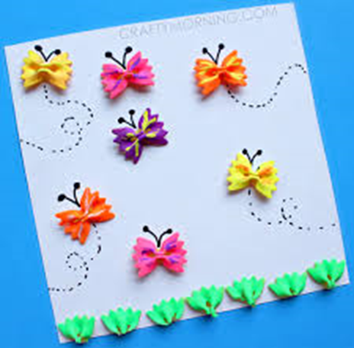
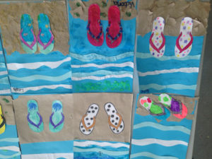
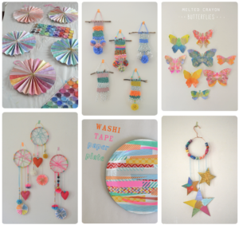

A few other ideas if you have some free time!!
READING: It is so important that you read every day.
- You can access a huge range of books HERE- Worldbook Username: wbsupport Password: distancelearn
- David Walliams audiobook stories are available from 11am every day click HERE
- Click HERE to do some coding activities.
- Watch 'School on TV' Live on RTÉ 2 weekdays from 11am-12pm
- BBC Bitesize have three new lessons every weekday, with videos, activities and more- click HERE

